Introducing the Trust in Government (TrustGov) Dataset: A New Resource for Cross-National, Time-Series Trust Research

# Authors

* Yuehong Cassandra Tai, corresponding author, ORCID: <https://orcid.org/0000-0001-7303-7443>, Assistant Research Professor, Center for Social Data Analytics, Pennsylvania State University, [yhcasstai@psu.edu](mailto:yhcasstai@psu.edu)

# Data and Code Availability

The code used to generate the dataset and conduct validation test are openly available at: <https://github.com/Tyhcass/TGOV>.

# Conflict of Interest Disclosure

The author declares no competing interests.

# Acknowledgements

# Introduction

Trust is central to understanding political, social, and economic life. It is shaped by factors such as inequality, corruption, election integrity, and government performance, and in turn underpins regime support, influences policy preferences, and conditions public responses during crises such as COVID-19 (for reviews of trust’s dynamics, determinants, and consequences, see Levi and Stoker (2000); Citrin and Stoker (2018);Devine et al. (2021);Kerr et al. (2024)).

Although trust is a contested term, a common view is that trust is relational—directed at specific targets, such as other persons, groups, or institutions-and rarely unconditional(Levi and Stoker, 2000). Two main forms are political trust and social trust. Political trust refers to “trust in a specific actor or institution” (Devine, 2024), with different proposed dimensions,such as trust in representative vs. implementing institutions, or in political institutions vs. authorities (see more discussion at Tai (2022: pp32–34)). Social trust refers to “trust in human targets”(Dinesen et al., 2020), including generalized social trust, particularized trust, and trust in specific groups.

Because political trust is essential to regime legitimacy, it has attracted extensive scholarly attention (Citrin and Stoker, 2018). Yet, despite its prominence, testing trust-related theories comparatively has been constrained by a lack of comprehensive cross-national, time-series data. Existing resources are often fragmented, limiting rigorous comparison of trust dynamics across political and regional contexts (Kerr et al., 2024). Much work focuses on a single country (often the U.S. or U.K.), and even comparative studies concentrate on particular regions or democracies (Devine, 2024). The lack of time-series comparative trust data makes it impossible to examine the dynamics between trust, its determinants—such as governance performance, inequality, and corruption—and its consequences, including regime support, voting behavior, and policy compliance.

To address this gap, I introduce a time-series cross-national trust in national government dataset (TrustGov), covering 115 countries/territories from 1973 to 2020. As mentioned before, scholars classify dimensions of political trust in multiple ways, and a full discussion of these approaches is beyond this paper’s scope. However, as with other comparative public attitude measures that lack multidimensionality (Hu et al., 2025), most empirical measures of political trust remain blunt. Differentiating the object of trust helps capture its multidimentionality and support future studies (Devine, 2024). This dataset focuses on national government as a specific object of political trust, because trust in national government has broader relevance across social science from public health and behavioral science to economics, law, public policy, and environmental studies.

Using a Bayesian latent variable model developed by Solt (2020b), this dataset synthesizes various survey sources into comparable trust estimates, drawn from 189 with 2,136 country-year-item covering 47 years. In addition to mean estimates, I release full posterior draws so scholars can explicitly incorporate measurement uncertainty inherent in latent variable modeling. With its temporal and cross-national coverage, TrustGov facilitates comparative research on the causes and consequences of trust in government, advancing our understanding of democratic governance, electoral behavior, policy development, and related areas.

# Data & Methods

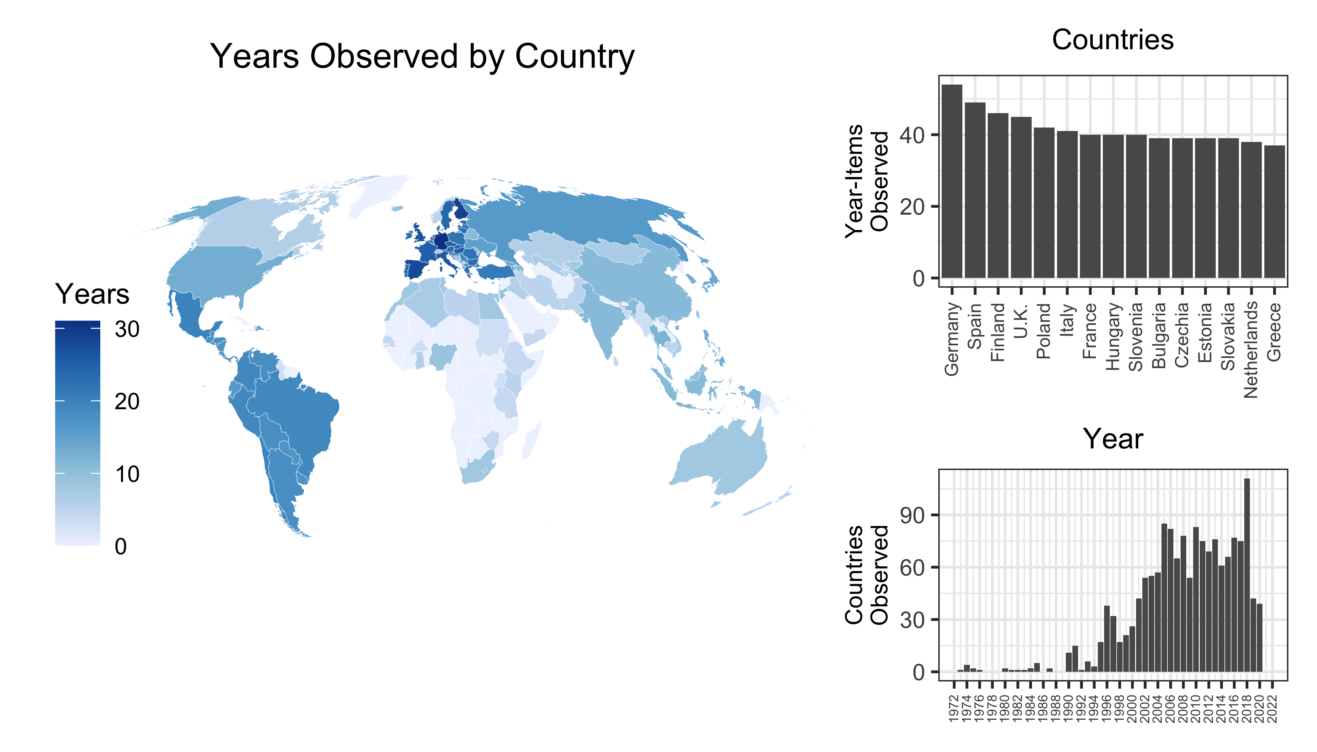

Figure 1: Countries and Years with the Most Observations in the Source Data of Trust in Government

## Raw Data

Although many national and cross-national surveys have asked questions on trust in national government, comparative data at the aggregate level is sparse and fragmented. This fragmentation is primarily due to limited coverage across countries and years, as well as inconsistencies in question wording and interpretation.

To construct a dynamic and comparable dataset, I systematically reviewed 189 unique survey projects spanning 116 countries/territories over 47 year. I identified 10 unique survey questions that captured public attitudes toward trust in national government. To improve comparability and reduce uncertainty from sparse data, I excluded rarely asked survey items.

In the country-years span, among the 2,674 country-years, 58% of it has available information. However, if we have observations for every year in each country surveyed, the total would be 5,452. In fact, even collecting as much available national and cross-national data as possible, the current source data has 1,555 country-years which are 29% of a complete set of total country-year.

The left panel of Figure maps the global distribution of observed country-years. European and Latin American countries have longer time series due to the frequent fielding of Eurobarometer and AmericasBarometer surveys, as well as strong scholarly interest in democratic and emerging regimes. In contrast, data from Asian and African countries is limited. The upper right panel further illustrates this geographical disparity: Germany leads with 54 country-year-item observations, followed by Spain and Finland. The lower right panel shows that few relevant survey items existed before 1990. Country coverage peaked in 2018, when respondents in 111 countries were asked about trust in government. Overall, although such questions appeared as early as the 1970s, they were not surveyed regularly or broadly until the 1990s, and coverage has remained geographically uneven.

In the next section, I describe how sparse and non-comparable survey data are harmonized into comparable time-series trust estimates using a latent variable model.

## Measurements

Latent variable measurement assumes the concept of interest is not directly observable but can be inferred from individuals’ responses to relevant questions. Recently, pioneering studies have developed latent variable models specifically tailored to cross-national survey data (Caughey et al., 2019; see Claassen, 2019; Kołczyńska et al., 2024; McGann et al., 2019). In this paper, I adopt the Dynamic Comparative Public Opinion (DCPO) model developed by Solt (2020b), which provides a better fit to survey data compared to alternatives (Caughey et al., 2019; Claassen, 2019), and effectively manages sparsity without requiring dense coverage or auxiliary population characteristics (Kołczyńska et al., 2024; McGann et al., 2019).

The DCPO model can address two principal challenges posed by the source data: incomparability and sparsity. To tackle incomparability across survey questions, the model includes two parameters. The *difficulty* parameter captures how much trust is required to endorse a response (e.g., “a great deal” vs. “somewhat”), and the *dispersion* parameter indicates how sensitively responses reflect changes in the latent trust level. A lower dispersion score means that a small change in responses corresponds to a substantial shift in the latent trait. Questions that are asked widely across countries and years anchor item parameters with greater precision, while rare items provide weaker information. By estimating item difficulty and dispersion and leveraging common items as anchors, DCPO maps responses from different questions and surveys on a single latent scale, yielding comparable country–year estimates. In simple terms, different questions are aligned onto the same scale, with widely asked questions stabilizing that scale.

To handle sparsity, DCPO adopts random-walk priors within countries, estimating missing latent values as the previous year’s trust level plus a small random shock. If a year lacks survey data, the estimate is informed by the most recent available data point in that country. The introduced uncertainty is greater when there are longer gaps without survey data. As shown in Figure , the geographical and temporal distribution of raw data is uneven: European countries generally have dense time series, while African and Asian countries often have fewer observations. Consequently, estimates from data-rich contexts rely more directly on survey responses and carry less uncertainty, whereas estimates from data-sparse contexts carry greater uncertainty. This uncertainty propagates into downstream analyses, indicating that results and inferences based on data-sparse contexts should be interpreted with greater caution. Although estimates are smoothed over time to provide continuous coverage, they retain inherent uncertainty. For details on the DCPO model, see Solt (2020b: 3–8). Approaches for incorporating this uncertainty into downstream analyses are discussed later.

I estimated TrustGov scores using the DCPO package for R (Solt, 2020a). The resulting country–year estimates constitute the TrustGov scores.

# Results

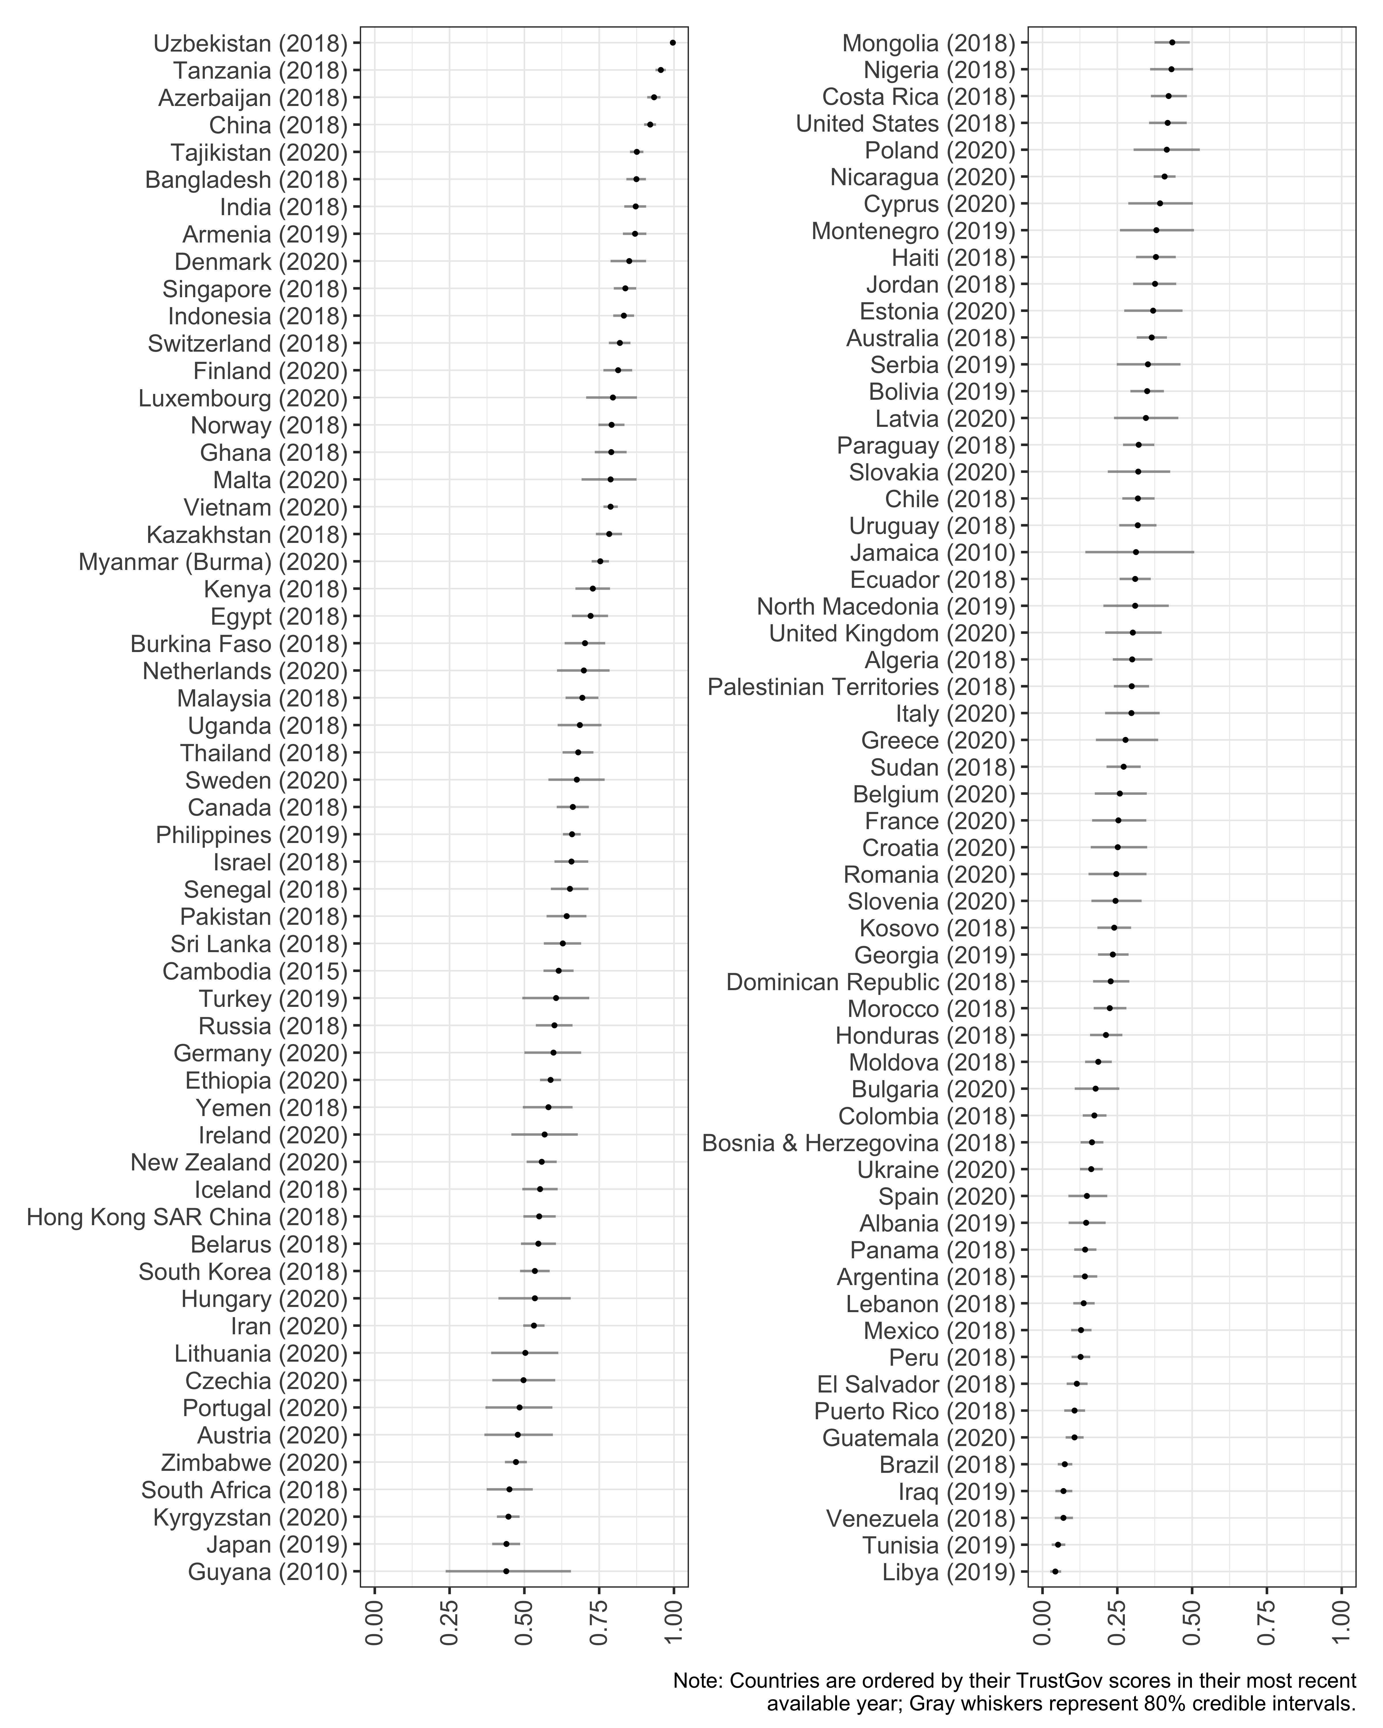

Figure 2: TrustGOV Scores, Most Recent Available Year

Figure displays the most recent available TrustGov score for each of the 115 countries/territories in the dataset. China and several Central Asian countries dominate the top positions, consistent with previous research indicating high levels of trust in these governments (Byaro and Kinyondo, 2020; Paturyan and Melkonyan, 2024; Schneider, 2017). Less corrupt countries like Denmark and Switzerland also rank highly, while Libya, Tunisia, Venezuela, Iraq, and Brazil show the lowest recent scores. These lower-ranked countries faced serious challenges around the time of measurement, including corruption (Venezuela, Iraq), election-related violence (Brazil), and conflict or security threats (Tunisia, Libya).

There are well-known concerns about the authenticity of self-reported data in authoritarian contexts, especially for sensitive questions (Blair et al., 2020). However, empirical evidence is mixed—some studies find sensitivity biases are typically small (Blair et al., 2020), while others suggest systematic misreporting under certain conditions (e.g., Tannenberg, 2021), and still others find little evidence of bias in cases such as China (Tang, 2016). Both high- and low-trust countries in Figure include regimes classified as partly free or not free by Freedom House (2024), indicating that self-censorship or political wariness cannot by themselves explain why some authoritarian countries report high trust while others report low trust. In addition, although respondents’ understanding and reporting of political trust may differ across regime types, prior research has shown that latent variable models can measure trust in central political institutions comparably across contexts (Schneider, 2017). For transparency, I therefore report all results, while future research should continue to investigate the dynamics of trust in authoritarian contexts.

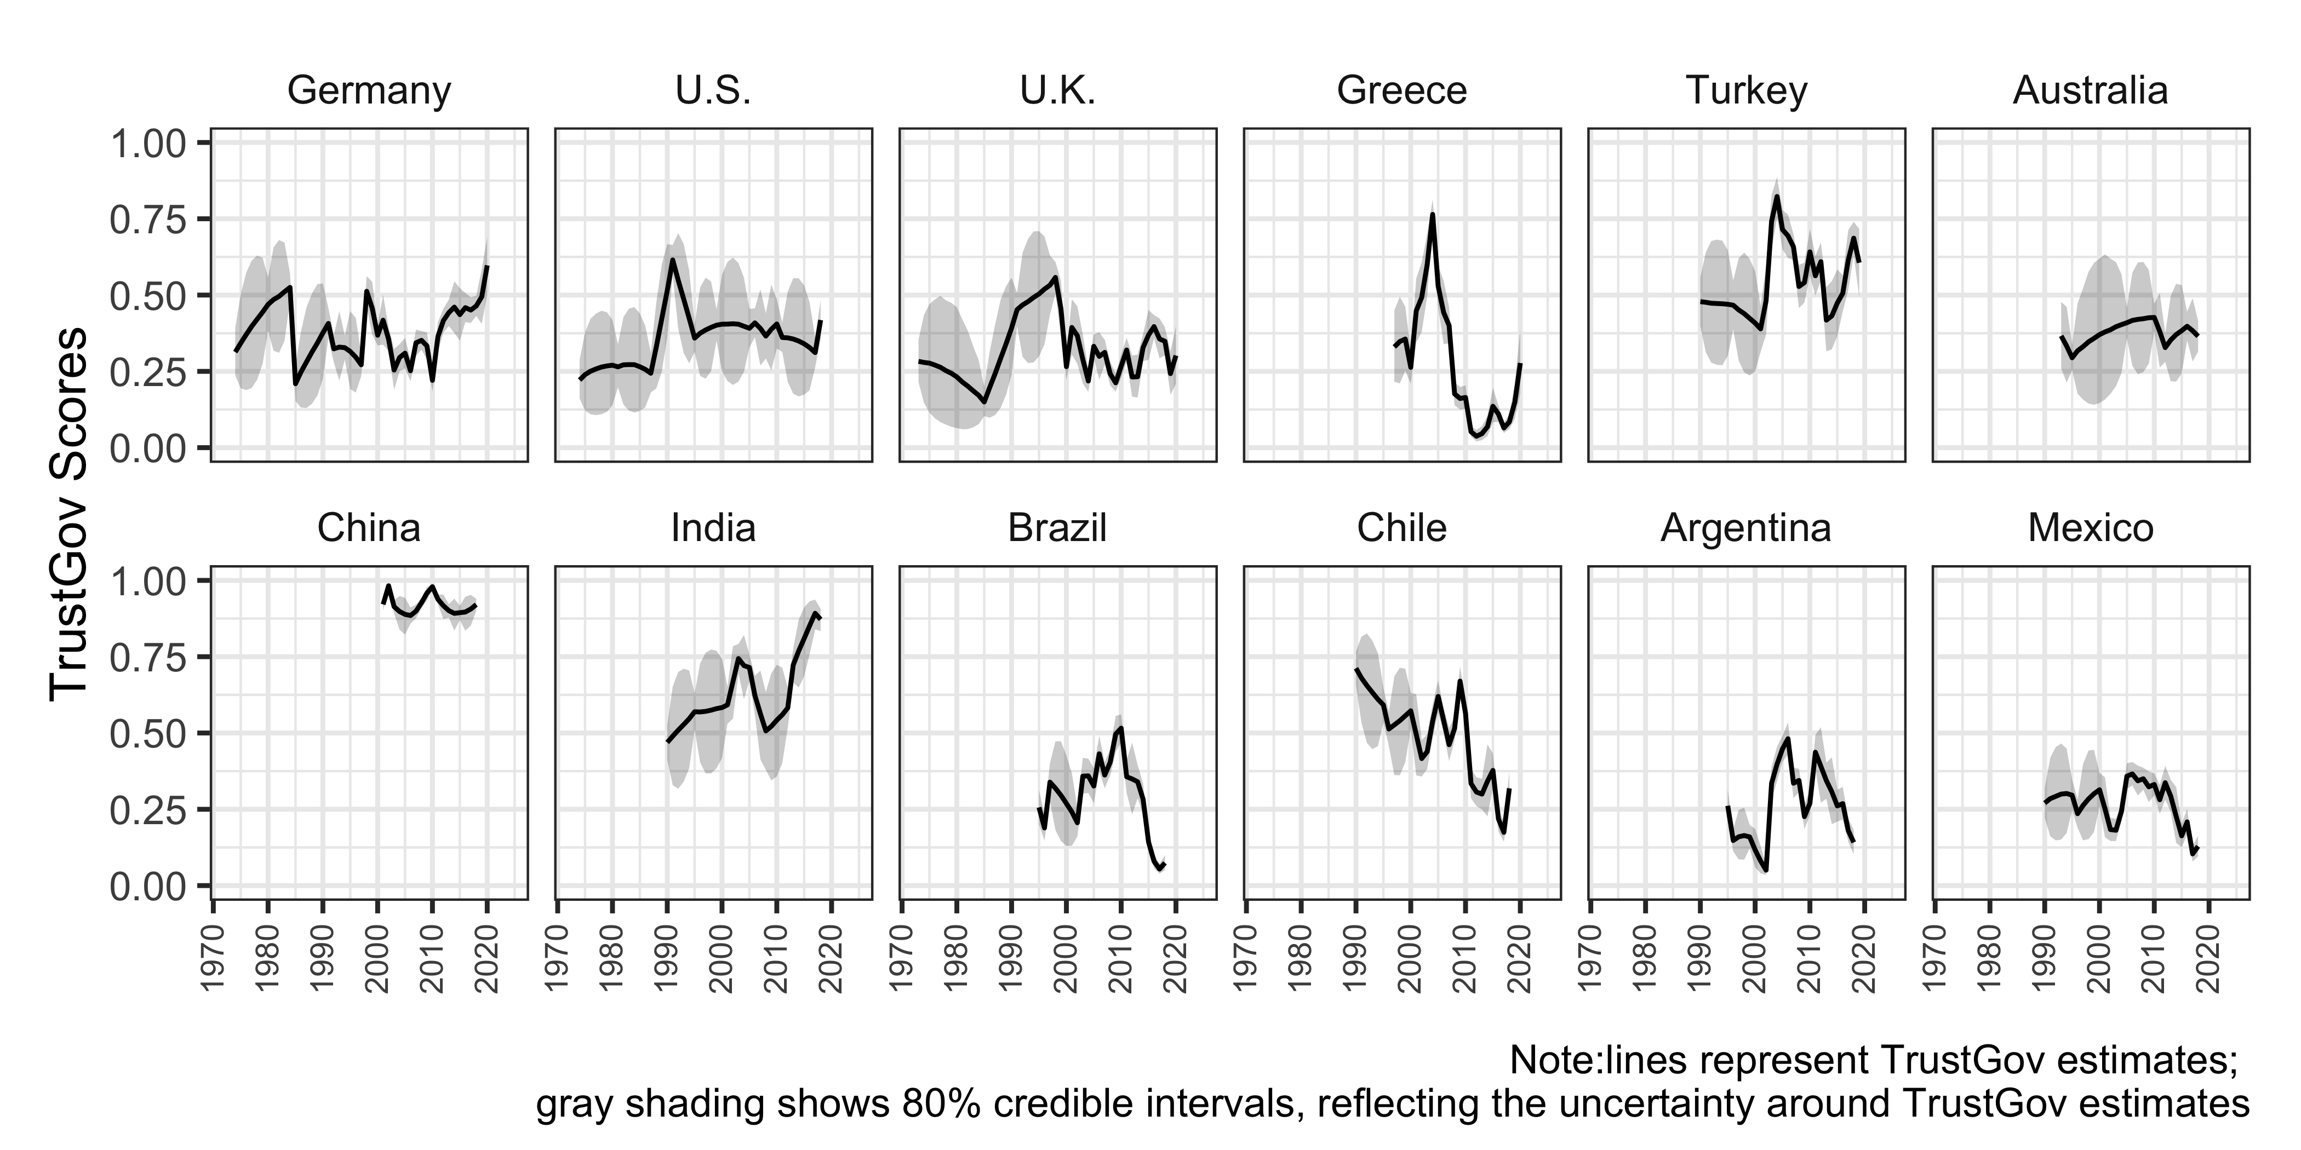

Figure 3: TrustGov Scores Over Time Across Selected Countries, 1973–2020

Figure illustrates how TrustGov scores evolve differently across 12 selected countries, with sharp increases in some contexts and long-term declines in others. For example, trust in government has risen prominently in countries such as Germany, India, the Philippines, and Nigeria—likely due to stable governance under Merkel in Germany and Modi in India (OECD, 2025; Sardesai and Shastri, 2023), populist administration policies in the Philippines (Curato, 2017), and reduced violence levels in Nigeria (Harding and Nwokolo, 2024). In contrast, trust has remained consistently high in China and relatively low in Australia.

TrustGov scores have declined steadily or dramatically in Greece, Mexico, Argentina, and the United States, primarily due to economic crises in Greece (Ervasti et al., 2019), widespread corruption in Mexico (Morris and Klesner, 2010), financial instability and political dysfunction in Argentina (Council on Foreign Relations, 2024), and rising political polarization and partisanship in the United States (Hetherington and Rudolph, 2018).

Some countries exhibit fluctuations. In the United Kingdom, fluctuations could be associated with Brexit, sovereignty debates, and immigration issues (Guardian, 2025). In Turkey, shifts may reflect the personalization of political power and economic volatility (Pew Research Center, 2024).

These visualizations show uncertainty in the estimates through the width of the 80% credible intervals and highlight the need for caution in interpretation. It is also worth noticing that the current dataset ends in 2020, coinciding with the onset of the COVID-19 pandemic. Post-2020 trends may deviate sharply from earlier trajectories, as some governments experienced surges of public trust during crisis response while others saw declines. The next data release will incorporate post-2020 surveys to capture these dynamics. Meanwhile, the cross-national and temporal variation already present in TrustGov scores invites in-depth analysis.

To ensure their validity across contexts and over time, I conducted a series of convergent and construct validation tests.

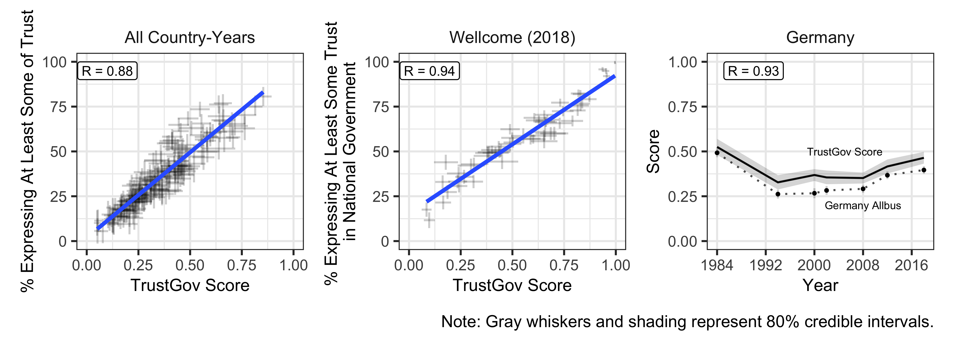

Figure 4: Convergent Validation Through Individual TrustGov Source Data Survey Items

Convergent validation tests whether a measure is empirically associated with alternative indicators of the same concept (Adcock and Collier, 2001: 540). I conducted ‘internal’ convergent validation (see, e.g., Caughey et al., 2019: 689; Solt, 2020b: 10) by comparing TrustGov scores against individual source items used in estimation.

Figure presents three validation plots comparing TrustGov scores with the percentage of respondents expressing at least some trust—calculated using responses equal to or above the median value of each scale. The left panel shows a scatterplot of country-years in which the TrustGov scores are plotted against responses to the Eurobarometer question: “Please tell me how much you personally trust each of the following institutions using a scale from 1 to 10, where [1] means ‘you do not trust the institution at all’ and [10] means ‘you trust it completely’.” The strong correlation (R = 0.88) indicates that TrustGov scores effectively capture variations in trust across country-years.

The middle panel compares TrustGov scores with the responses to the question: “How much do you trust the national government in your country?” from the Wellcome Global Monitor Survey in 2018. This item was asked in more countries than any other trust question in a single survey over the past decade, and the strong correlation (R = 0.94) demonstrates the broad applicability of TrustGov scores across diverse contexts.

Finally, the right panel compares TrustGov to the trend of the longest-running item in the Germany ALLBUS survey since 1984: “How much trust do you place in the federal government?” TrustGov scores align with the observed trend [R = 0.93], effectively capturing historical changes. In all tests, the correlations are estimated while incorporating measurement uncertainty.

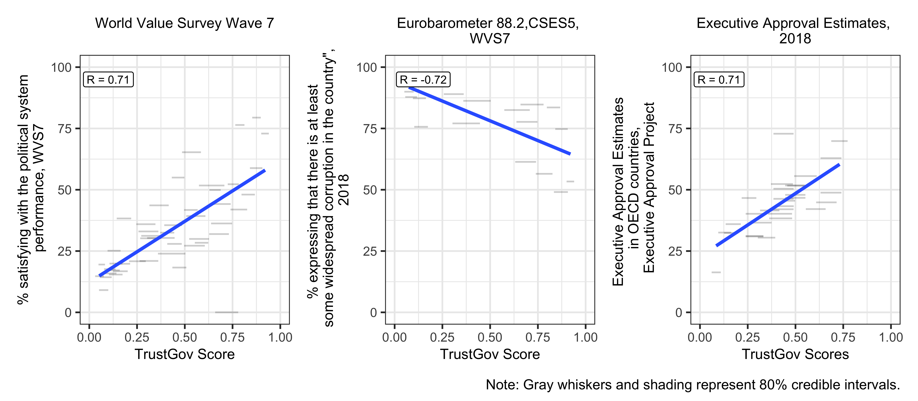

Figure 5: Construct Validation Using Perceived Corruption, Satisfaction, and Approval Rating Data

Construct validation, which assesses whether a measure empirically correlates with other indicators that are theoretically expected to be causally related (Adcock and Collier, 2001: 542), was also conducted. I focused on three such indicators: the public’s satisfaction with political system performance, the public’s perception of corruption, and executive approval ratings. Abundant research has shown that trust is a strong predictor of satisfaction with political system performance (Hetherington and Rudolph, 2018) and approval ratings (Citrin and Luks, 2001), while also being undermined of perceived corruption (Anderson and Tverdova, 2003).

The results are presented in Figure. The left panel shows a clear positive relationship [R = 0.71] between TGOV scores and satisfaction with political system performance, measured as the percentage of individuals expressing at least some satisfaction in the WVS Wave 7.

A similar positive correlation [R = 0.71] between TrustGov scores and executive approval ratings appears in the right panel. The approval ratings are drawn from smoothed estimates for OECD countries in 2018 from the Executive Approval Project (version 2) (Carlin Ryan et al., 2019).

The center panel shows a negative relationship [R = -0.72] between TrustGov scores and perceptions of widespread corruption, as surveyed in Eurobarometer, the Comparative Study of Electoral Systems (CSES), and the WVS in year of 2017. In all three tests, the direction of correlation aligns with theoretical expectations.

In sum, the convergent and construct validations provide strong evidence that the TrustGov scores are a valid measure of trust in national government.

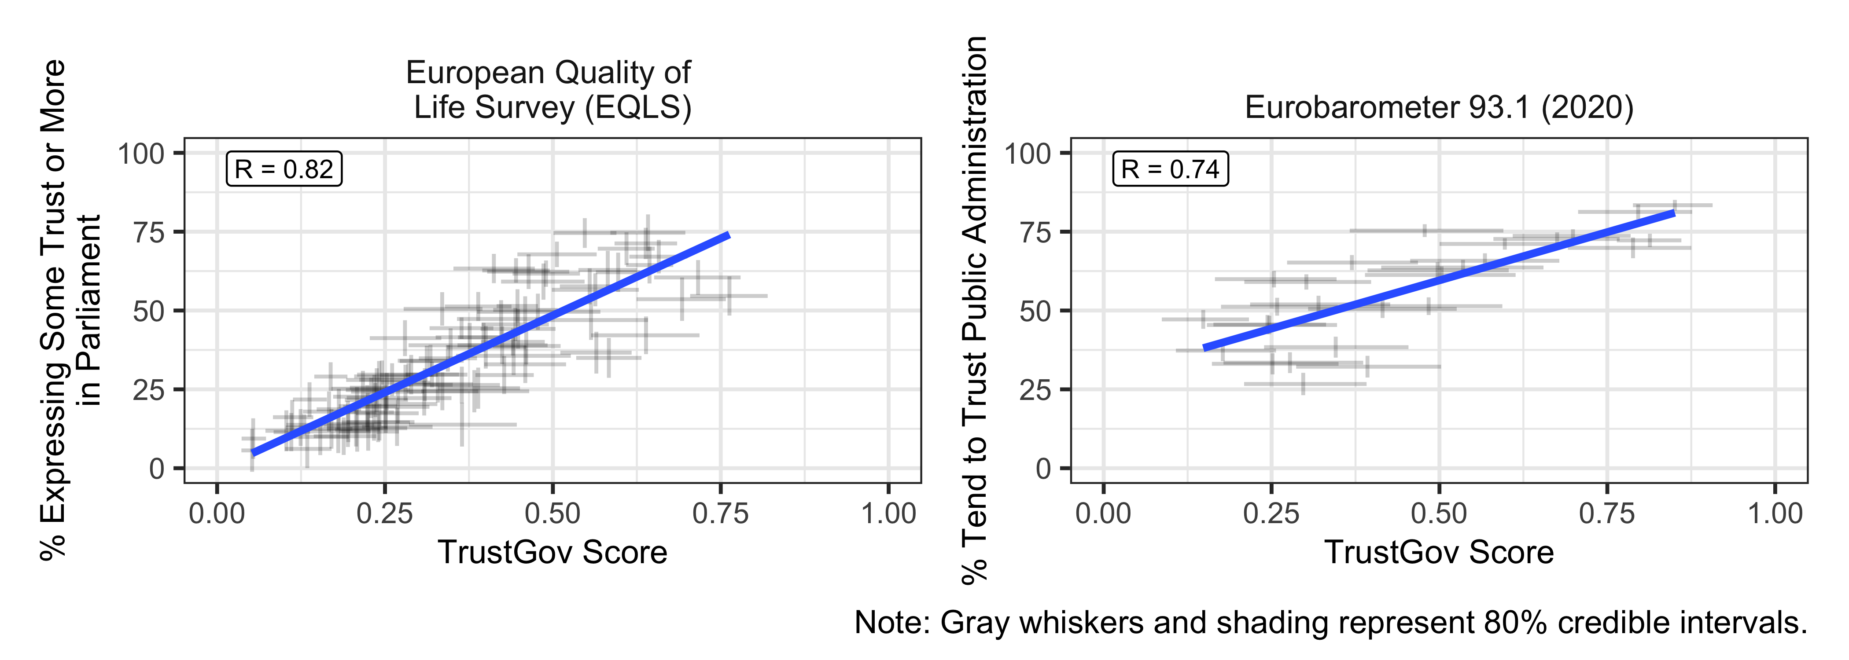

Figure 6: Additional Validation Test Using Data of Trust in Parliament and Trust in Public Administration

In addition to the tests above, I also examined survey items that were not part of the TrustGov score estimation but are empirically closely related to trust in government, trust in parliament and trust in public administration. Although the classification of dimensions of political trust is debated, empirically, trust in government typically mirrors trust in parliament, and the two are often grouped together as indicators of political trust (Dellmuth, 2024; Meer and Erkel, 2024). Likewise, although scholars discuss distinctions between trust in government and trust in public administration, empirical results show that these two types of trust are closely, positively related (see more discussion at Camões and Mendes, 2019).

In Figure, the TrustGov scores are compared against public confidence in parliament from the European Quality of Life Survey (EQLS) in the left plot and against the percentage of respondents who expressed trust in public administration in their country, as measured by Eurobarometer, in the right panel.

Across both tests, the TrustGov measure was positively correlated with the these related forms of institutional trust, with stronger correlation for trust in parliament[R = 0.82], and moderate correlation for trust in public administration [R = 0.74].

# Discussion & Conclusion

Although political trust is a long-standing interdisciplinary topic, much of our understanding remains limited to single countries or regions with rich longitudinal data that may not generalize elsewhere, or to cross-sectional snapshots that cannot capture dynamic changes over time (Kołczyńska et al., 2024). The TrustGov dataset addresses this gap by providing comparable time-series cross-national measures of trust in government. It provides a foundation for investigating the causes and consequences of trust in government across contexts and over time, for example, how trust shapes attitudes toward climate change and public health policies, or how it interacts with polarization, personalist leaders, and crisis management.

TrustGov also supports qualitative and mixed-methods research. Researchers can use TrustGov trends to identify countries or periods with sharp shifts in trust and explore them further through case studies. Identified turning points can be examined with process tracing or interviews to probe the mechanisms behind quantitative shifts. The dataset also facilitates classic comparative strategies, such as most similar systems design and most different systems design. Researchers can select countries with similar contexts but divergent trust trajectories, or countries that differ in most respects yet nonetheless display similar trust patterns. In this way, TrustGov connects large-scale patterns with fine-grained qualitative accounts, enabling researchers to contextualize and enrich explanations of how trust develops in specific settings.

Although TrustGov offers a valuable resource for studying trust in government, it also has limitations. First, as an aggregate-level dataset, it may obscure subnational variation, polarization in trust, or case-specific dynamics that require country expertise and qualitative or mixed methods to illuminate. Second, the smoothing approach introduces measurement uncertainty, and ignoring uncertainty risks distorting inferences (Tai et al., 2024). To mitigate this, I provide full posterior draws so that researchers can incorporate uncertainty directly into their downstream analysis (e.g., Caughey and Warshaw, 2018; Tai et al., 2024; Woo et al., 2025). Finally, the current dataset ends in 2020. The COVID-19 pandemic might have reshaped trust in many countries. Researchers should be mindful of this temporal boundary when drawing inferences.

The TrustGov project will continue to be updated and improved. The next planned release will incorporate surveys conducted after 2020, including post-pandemic waves. Future releases will expand the dataset on a rolling basis as new cross-national surveys become publicly available.

# References

Adcock R and Collier D (2001) Measurement validity: A shared standard for qualitative and quantitative research. *American political science review* 95(3). Cambridge University Press: 529–546.

Anderson CJ and Tverdova YV (2003) Corruption, political allegiances, and attitudes toward government in contemporary democracies. *American journal of political science* 47(1). Wiley Online Library: 91–109.

Blair G, Coppock A and Moor M (2020) When to worry about sensitivity bias: A social reference theory and evidence from 30 years of list experiments. *American Political Science Review* 114(4). Cambridge University Press: 1297–1315.

Byaro M and Kinyondo A (2020) Citizens’ trust in government and their greater willingness to pay taxes in tanzania: A case study of mtwara, lindi, and dar es salaam regions. *Poverty & Public Policy* 12(1). Wiley Online Library: 73–83.

Camões PJ and Mendes SM (2019) Do citizens trust the civil service differently? Comparing the determinants of confidence in political-administrative institutions. *International Journal of Public Administration*. Taylor & Francis. Epub ahead of print 2019.

Carlin Ryan E, Jonathan H, Timothy H, et al. (2019) Executive approval database 2.0.

Caughey D and Warshaw C (2018) Policy preferences and policy change: Dynamic responsiveness in the american states, 1936–2014. *American Political Science Review* 112(2). Cambridge University Press: 249–266.

Caughey D, O’Grady T and Warshaw C (2019) Policy ideology in european mass publics, 1981–2016. *American Political Science Review* 113(3). Cambridge University Press: 674–693.

Citrin J and Luks S (2001) Political trust revisited: Déjà vu all over again? *What is it about government that Americans dislike*. Cambridge University Press Cambridge: 9–27.

Citrin J and Stoker L (2018) Political Trust in a Cynical Age. *Annual Review of Political Science* 21(1): 49–70.

Claassen C (2019) Estimating smooth country–year panels of public opinion. *Political Analysis* 27(1). Cambridge University Press: 1–20.

Council on Foreign Relations (2024) Argentina’s struggle for stability. <https://www.cfr.org/backgrounder/argentinas-struggle-stability>.

Curato N (2017) Flirting with authoritarian fantasies? Rodrigo duterte and the new terms of philippine populism. *Journal of Contemporary Asia* 47(1). Taylor & Francis: 142–153.

Dellmuth L (2024) Regional inequalities and political trust in a global context. *Journal of European Public Policy* 31(6). Taylor & Francis: 1516–1535.

Devine D (2024) Does political trust matter? A meta-analysis on the consequences of trust. *Political Behavior* 46(4). Springer: 2241–2262.

Devine D, Gaskell J, Jennings W, et al. (2021) Trust and the coronavirus pandemic: What are the consequences of and for trust? An early review of the literature. *Political Studies Review* 19(2). SAGE Publications Sage UK: London, England: 274–285.

Dinesen PT, Schaeffer M and Sønderskov KM (2020) Ethnic diversity and social trust: A narrative and meta-analytical review. *Annual Review of Political Science* 23(1). Annual Reviews: 441–465.

Ervasti H, Kouvo A and Venetoklis T (2019) Social and institutional trust in times of crisis: Greece, 2002–2011. *Social Indicators Research* 141. Springer: 1207–1231.

Freedom House (2024) Freedom in the world 2024. Available at: <https://freedomhouse.org/report/freedom-world>.

Guardian T (2025) How COVID changed the way we think. Available at: <https://www.theguardian.com/uk-news/2025/mar/17/how-covid-changed-the-way-we-think>.

Harding R and Nwokolo A (2024) Terrorism, trust, and identity: Evidence from a natural experiment in nigeria. *American Journal of Political Science* 68(3). Wiley Online Library: 942–957.

Hetherington MJ and Rudolph TJ (2018) Political trust and polarization. *The Oxford Handbook of Social and Political Trust*. Epub ahead of print March 2018.

Hu Y, Tai YC, Ko H, et al. (2025) An incomplete recipe: One-dimensional latent variables do not capture the full flavor of democratic support. *Research & politics* 12(2). SAGE Publications Sage UK: London, England: 20531680251341857.

Kerr N, King BA and Wahman M (2024) The global crisis of trust in elections. *Public Opinion Quarterly*. SI. Oxford University Press.

Kołczyńska M, Bürkner P-C, Kennedy L, et al. (2024) Modeling public opinion over time and space: Trust in state institutions in europe, 1989-2019. In: *Survey research methods*, 2024, pp. 1–19. 1.

Levi M and Stoker L (2000) Political trust and trustworthiness. *Annual review of political science* 3(1). Annual Reviews 4139 El Camino Way, PO Box 10139, Palo Alto, CA 94303-0139, USA: 475–507.

McGann A, Dellepiane-Avellaneda S and Bartle J (2019) Parallel lines? Policy mood in a plurinational democracy. *Electoral Studies* 58. Elsevier: 48–57.

Meer TW van der and Erkel PF van (2024) Moving beyond the political trust crisis debate: Residual analyses to understand trends in political trust. *European Journal of Political Research* 63(3). Wiley Online Library: 1240–1257.

Morris SD and Klesner JL (2010) Corruption and trust: Theoretical considerations and evidence from mexico. *Comparative political studies* 43(10). SAGE Publications Sage CA: Los Angeles, CA: 1258–1285.

OECD (2025) Trust in government. <https://www.oecd.org/en/data/indicators/trust-in-government.html>.

Paturyan YJ and Melkonyan S (2024) Revolution, covid-19, and war in armenia: Impacts on various forms of trust. *Caucasus Survey* 1(aop). Brill Schöningh: 1–28.

Pew Research Center (2024) Turks lean negative on erdoğan, give national government mixed ratings. Available at: <https://www.pewresearch.org/global/2024/10/16/turks-lean-negative-on-erdogan-give-national-government-mixed-ratings/>.

Sardesai S and Shastri S (2023) Intensity of trust in institutions in india: The emerging paradox. *How Asians View Democratic Legitimacy*: 209.

Schneider I (2017) Can we trust measures of political trust? Assessing measurement equivalence in diverse regime types. *Social indicators research* 133(3). Springer: 963–984.

Solt F (2020a) DCPO: Dynamic comparative public opinion. Available at the Comprehensive R Archive Network (CRAN). https://CRAN.R-project.org/package=DCPO.

Solt F (2020b) Modeling dynamic comparative public opinion. SocArXiv. https://osf.io/ preprints/socarxiv/d5n9p.

Tai YC (2022) *The Role of Trust in Governance: Public Health and Tax Compliance in Cross-National Comparative Perspective*. The University of Iowa.

Tai YC, Hu Y and Solt F (2024) Democracy, public support, and measurement uncertainty. *American Political Science Review* 118(1): 512–518.

Tang W (2016) *Populist Authoritarianism: Chinese Political Culture and Regime Sustainability*. Oxford University Press.

Tannenberg M (2021) The autocratic bias: Self-censorship of regime support. *Democratization*. Taylor & Francis: 1–20.

Woo B-D, Ko H, Tai YC, et al. (2025) Public support for gay rights across countries and over time. *Social Science Quarterly* 106(1). Wiley Online Library: e13478.